Using SDF II in CLS

This text assumes a basic knowledge of SDF II. The suggested material is the SDF II VSE General Introduction from IBM bookshelf. The link would take you to the book directly. All chapters need not be covered as well. Chapters like 7, 9, 11, 12 and chapters from 14 to 21 are not mandatory for using SDF II in CLS. The basics of working here are covered in the remaining chapters.

- Setting up SDF II

Libraries are integral part of SDF II. In SDF II Main menu enter 8 to get to Specify Libraries section.

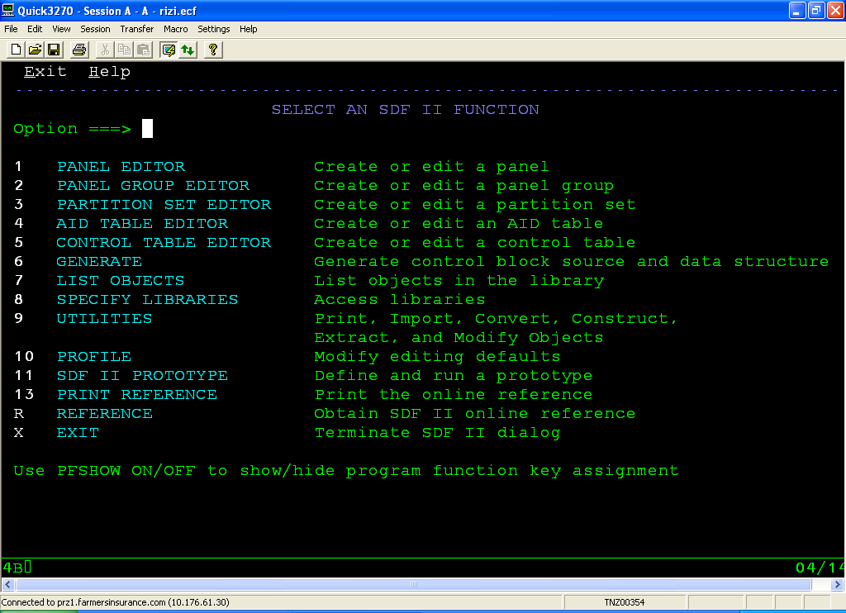

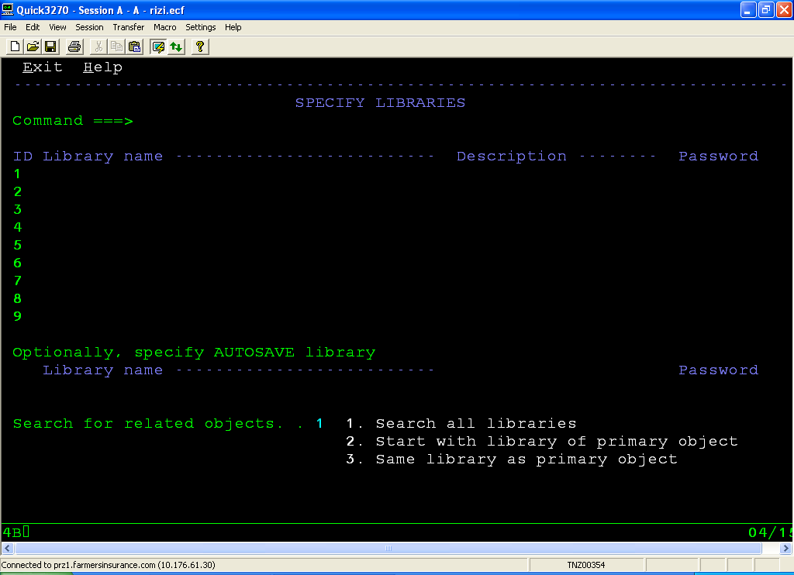

Specify the following libraries in order:

'CLST.DEV'
'CLST.TESTTRUK'
'SYS5.COMTEST.TRUCKA'
'SYS5.COMHOLD.TRUCKA'
'SYS5.HOT.TRUCKA'
'SYS5.HOT.TRUCKA'
'SYS5.PROD.TRUCKA'
'CLST.PRODTRUK'
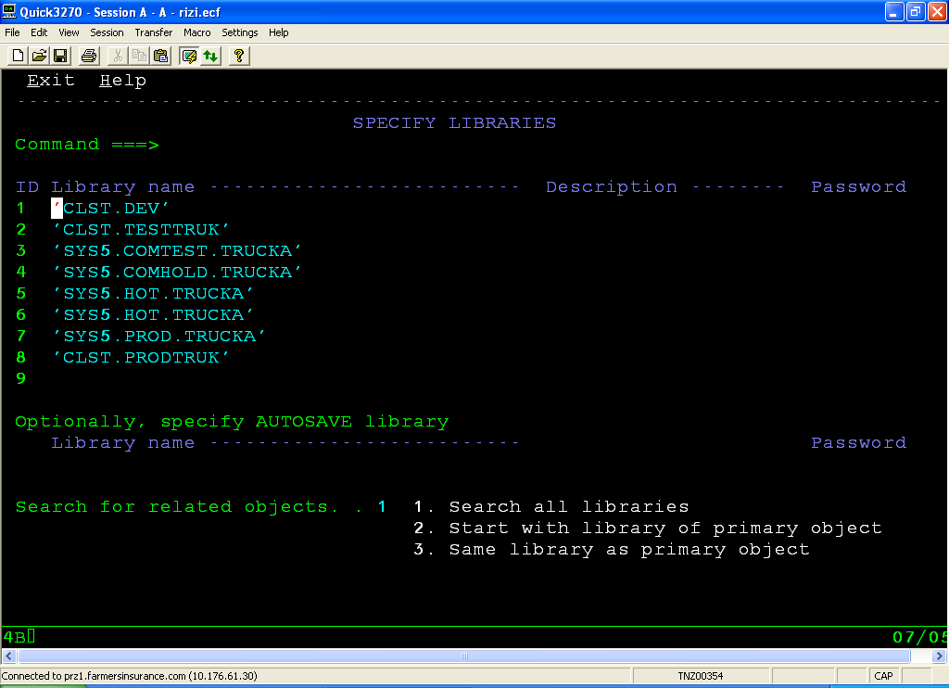

Press F3 to Save and Exit the section.

- Open an existing map.

  - Endevor Work

In Endevor search for the following members and add them to the directories specified below (the example used here is map A011 which comes in Screen S011 (Vehicle data capture screen):

Name Type PDS Description

A011MP1 $SDF2P CLST.DEV.DGIPNL Panel
A011SET $BMS CLST.DEV.BMSMACS BMS Macros generated by SDF II
A011SET $SDF2G CLST.DEV.DGIGRP Panel Group
A011SET COBCPY CLST.DEV.COMCOPY Copybook for the map

  - SDF II

In SDF II from the main menu enter 7 to get to the List Objects section. There enter the name of the map or alternatively enter the first few characters of the map with a wild character (*) to open both the Panel and Panel Group.

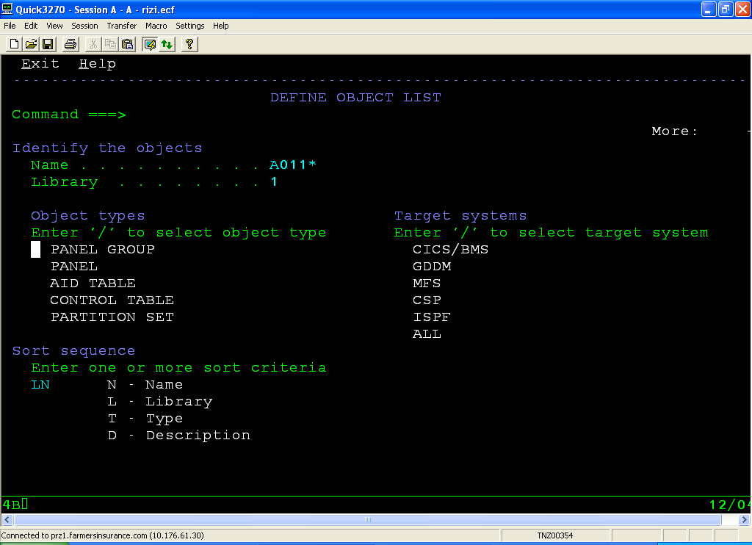

The panel and panel group are listed below:

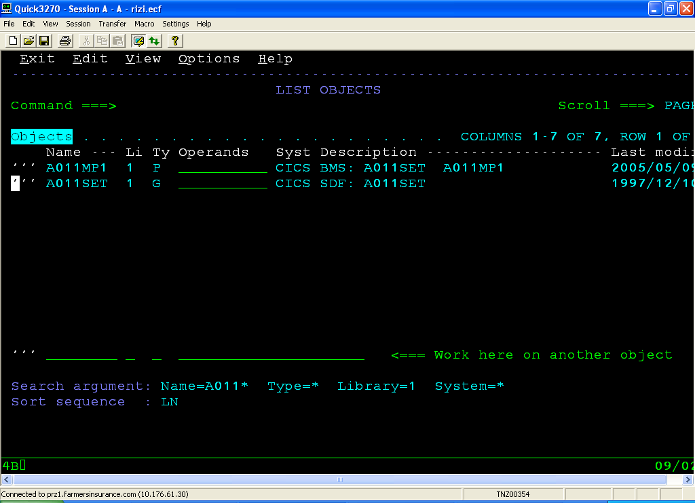

For almost all editing work we use the panel but the panel group is to be used while generating a mapset.

- Editing a map

Once the map is listed you specify an ‘E’ in the line command (to the left of the Name column) to edit the map. The Panel Editor dialog is displayed.

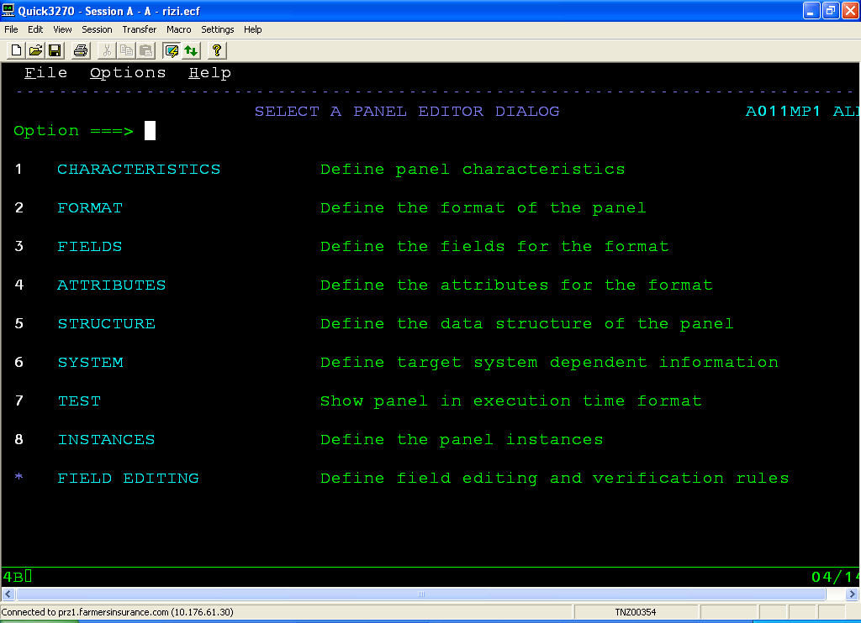

Here is where you edit the map.

3.1 Characteristics

It is better to leave it to defaults, unless you need to change the target system or storage class of a map. CLS has uniform characteristics for most maps.

3.2 Format

The format panel tells us the overall architecture of the map.
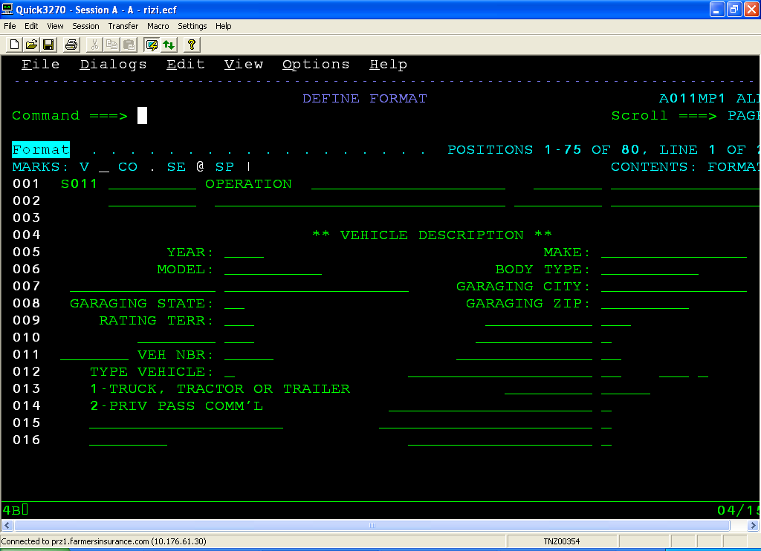

Changing the length of a pre-existing field or changing the literal names can be done from here. Adding a field is best done from the Fields section of panel editor.

3.3 Fields

This section contains the name, position and length of fields in the map (along with a format window at the lower part of the screen).

Field Naming Standards:

The first four characters are normally the first four characters of the map (A011 here). The field name prefixing option in Option 1.CHARACTERISTICS is not used by CLS and it the task of the developer to ensure this.
After the first four characters we can give a descriptive name to our field. Acronyms are also used. Literal fields are suffixed with ‘-LIT’ for clarity. Example, A011LOC-LIT, A011VSN-LIT

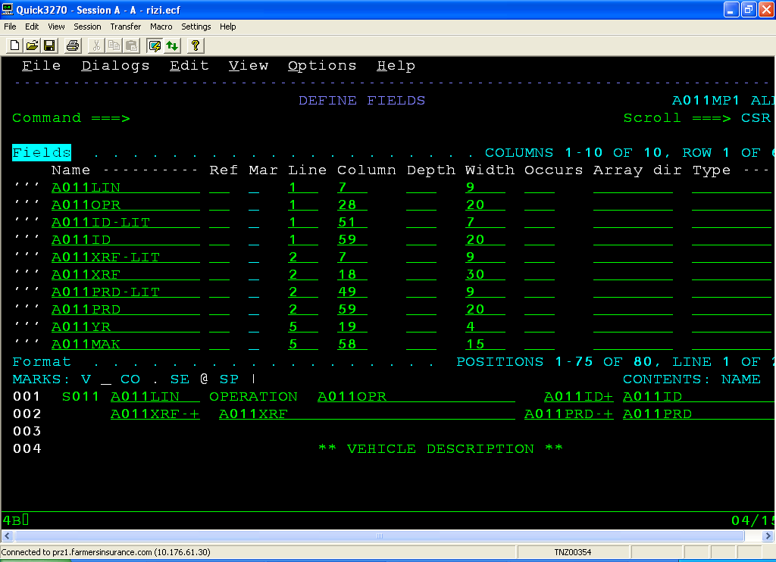

To add a field, simply insert a new line in the fields list and type the name and position, width of the field. The initial value option in Field Characteristics is used to give the initial values for literals.

3.4 Attributes

They specify the attributes in the format window but most importantly contain the attribute descriptors. A list of common attribute descriptors is provided below:

Des Attributes
A PR NOR CU
B PR NOR SK MD
C UNP NOR SK MD
D PR NOR
E PR BR
F PR BR SK
G UNP NOR SK NUM
H UNP NOR SK

The following screens illustrate how the fields are grouped using attribute descriptors.

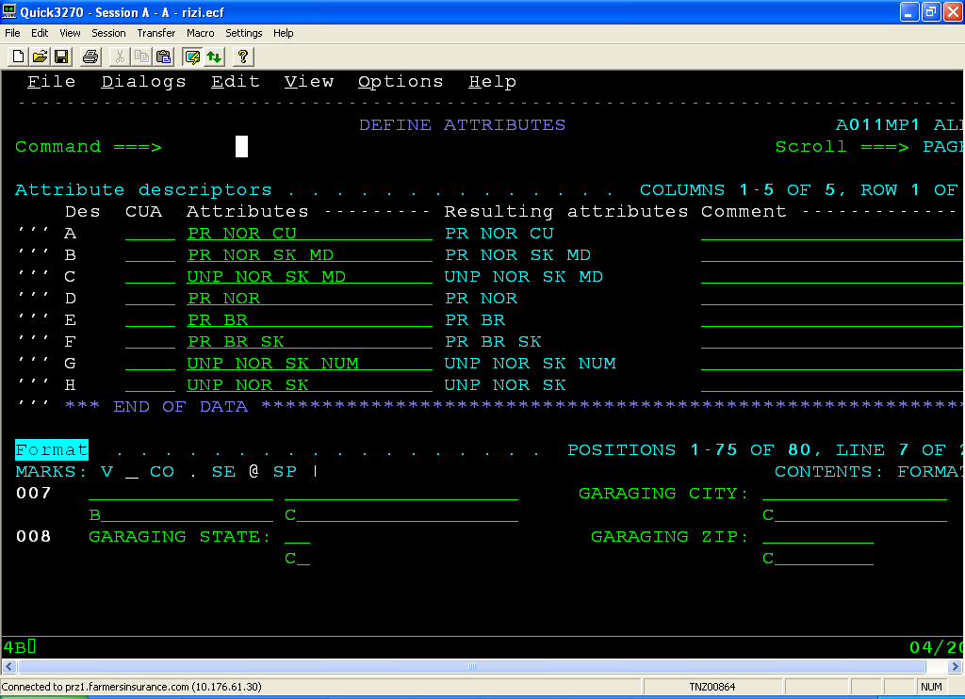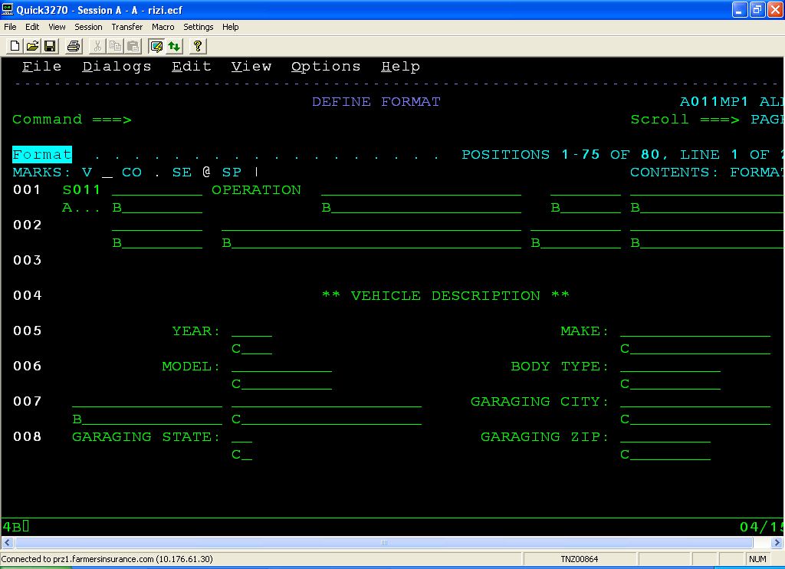
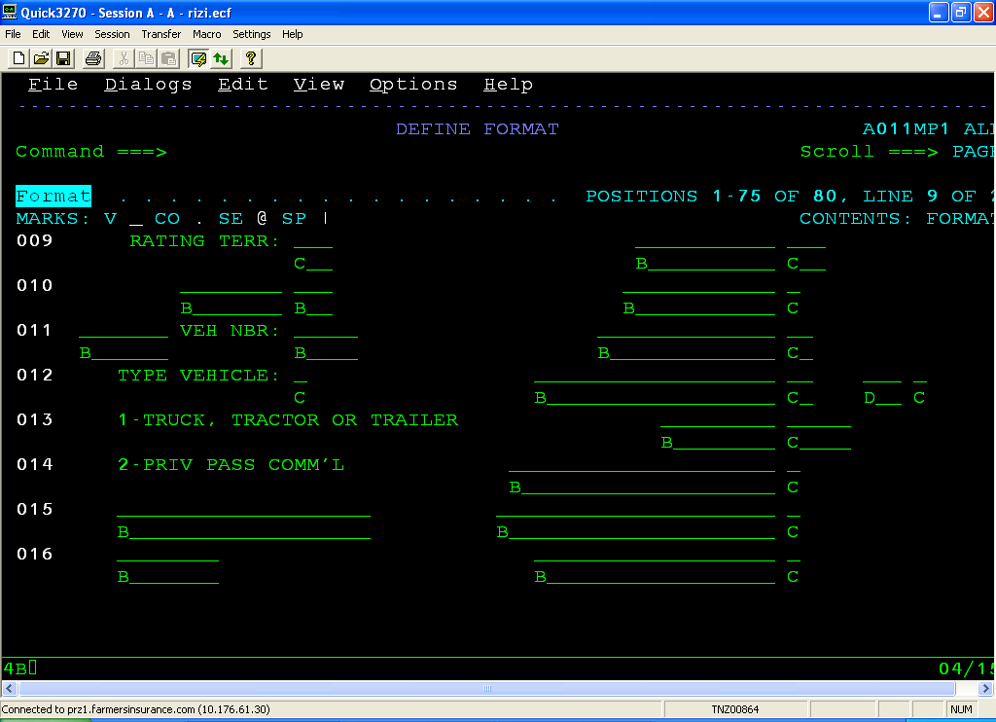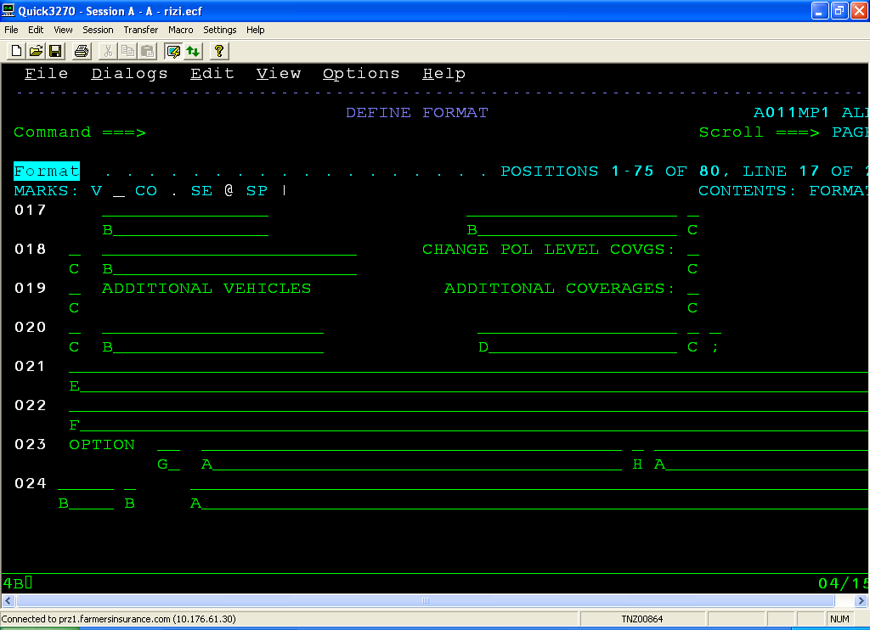

Apart from these the remaining options are seldom used (Except 7 Test).

- Generating the map

Once the changes are done press F3 from the panel editor dialog to return to the List Objects page. Now we have to generate the map and its associated copybooks and macros.
To generate the map enter ‘G’ in the line command of the Panel Group member as specified below:

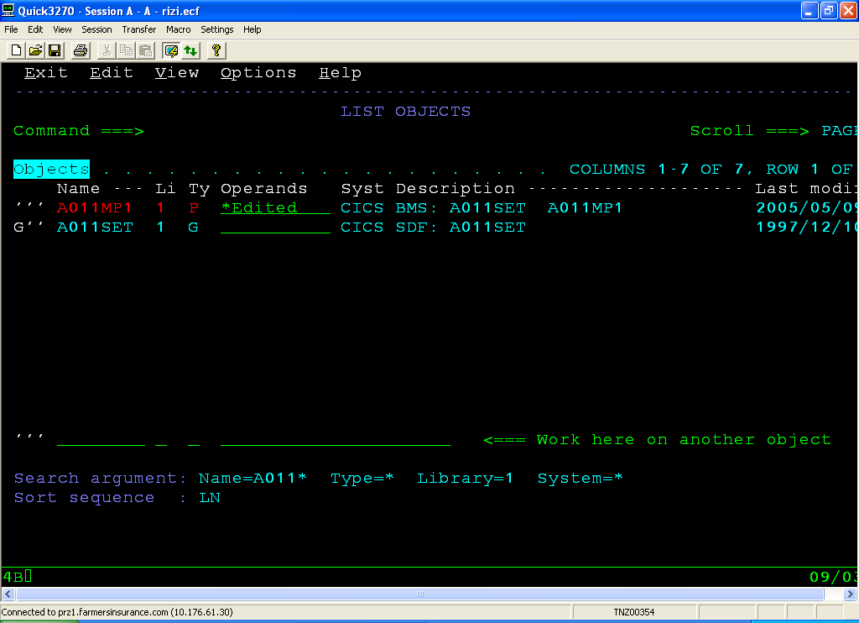

If you are generating for the first time you need to enter two PDS names, one for BMS Macros and other for output data structure. Enter them as CLST.DEV.BMSMACS and CLST.DEV.COMCOPY respectively. Once they are entered press enter and the map has been generated.

- Updating in Endevor.

This is trivial for all. Add the elements back into endevor as you had retrieved. The list is given again.

Name Type From PDS

A011MP1 $SDF2P CLST.DEV.DGIPNL
A011SET $BMS CLST.DEV.BMSMACS
A011SET $SDF2G CLST.DEV.DGIGRP
A011SET COBCPY CLST.DEV.COMCOPY

Once this is done the map is ready and you can instantaneously access it via CICS region.

The screen (S011/A011) used in this text is shown below for reference

